Golden Hill Elementary School
School Improvement Plan FY25-27
THEORY OF ACTION
By engaging students and families, strengthening literacy for all, setting high academic expectations, and preparing students for careers and active citizenship—while remaining fiscally responsible—we ensure that every student is ready to succeed in high school and beyond

Golden Hill Elementary School
Highlights and Challenges FY24-25

Highlights | Challenges
Goals 2 and 3  Academic Excellence - Walk-throughs and Data Collection with a focus on Literacy and Mathematics  -Walk-throughs were specific to Tier 1, ML, and SPED  -Specific strategies for feedback were given after each walk-through and within 2-3 days after the walk-through.  -The walk-throughs helped to identify the root of where we needed to improve (tier I, specifically providing appropriate scaffolds for our ML and Sped populations).  -We were able to collaborate with district leaders related to ML/SPED and curriculum supervisors.  -The ILT created and shared resources with all staff for improving scaffolds for all students  -The ILT and administration began to make clearer expectations for scaffolds and WIN blocks (having procedures and systems for WIN that were consistent across all grade levels).  -An action plan was created for FY2025-2026 based on the collected TNTP data. | -Providing staff with the Tier I support that they need to meet the drastically individualized needs of students.  -We have systems in place now for our WIN block (WIN boards across all grades), but we now need to support teachers in fine-tuning the WIN blocks to ensure that every student is getting what they need
Goals 1 and 4  Engagement and Positive Citizenship  -We were able to engage staff in professional development with our school-wide behavior support system (PAX and the PAX Reboot). PAX is consistently implemented across all grades with a focus on social-emotional learning and engagement.  -Our attendance team has a focus on identifying the root of attendance issues and then supporting the families and students appropriately.  -Our PTO and Site Council teams had a specific focus on Literacy and Engagement. The teams supported the purchase of books that connected to our curriculum for families to read with their children, as well as the implementation of reading log celebrations on Fridays.  -Families were invited into the school to celebrate their child’s writing - Wax Museum.  -Golden Hill had its first multicultural night, with over 20 families participating in showcasing their cultures and hundreds of families attending.  -Haverhill Public Library team members supported grades 1 and 2 with identifying and using library resources.  -We partnered with the YMCA for a family literacy night at the YMCA | Although we are connecting the curriculum to our family engagement nights, we will need to be more strategic with offering resources and identifying what our families need for support in moving students forward in their learning.  We recently had a PAX reboot, which supports citizenship and engagement (attendance), but we will need to ensure that the program continues to be at the forefront and embedded into the typical school day.

Golden Hill Elementary School
Strategic Objectives FY2025-2027

District Priorities | 1. Student and Family Engagement | 2. Literacy | 3. Academic Excellence | 4. Readiness for Careers and Citizenship
Golden Hill Priorities and Alignment with the District | Family and Community Engagement | Tiered System of Instruction for Literacy and Mathematics | Core Data Foundation to Support Academic Excellence | Ready for Citizenship / School-Wide Behavior Program (SEL)
Theory of Action | If family and community engagement is a shared responsibility that is viewed as valuable, and if those sharing the responsibility are committed to consulting and engaging families in school decisions, and if we, as community partners, are willing to implement a varied approach to engaging families from diverse backgrounds, then family and community engagement will be a meaningful contributor to increase student performance, greater social emotional wellness, and an improved culture. | If we, as a school, demonstrate a common and systematic understanding of Tier I instructional practices and expectations for teaching and learning to meet the needs of all students, including historically marginalized students, using a district-developed rubric of Tier I instructional practices and expectations, then all students will meet and exceed academic goals. | If we, as a school, demonstrate professional collaboration via shared data inquiry, and we are more intentional and targeted with our small groups for students who are identified as in need of further support, then we will have improved and documented instructional change for all students; this will be observed by ILT using action plans and action cycles. | If we continue to expand our knowledge of social emotional learning and if we continue to implement, with fidelity, our widely accepted and understood school-wide social emotional behavior plan, then we will create a caring and inclusive environment, which will, in turn, support all students in becoming productive and positive citizens.

Strategic Objective #1 Student and Family Engagement

SMARTIE GOAL: All Schools
Must include District-wide parent survey
  - A district-wide parent engagement survey will be administered by each school annually with questions about communication, involvement, and support for student learning. Results will be analyzed at the school and district level, compared year over year, and used for planning and improvement purposes.

SCHOOL GOAL ACTION ITEMS | Benchmarks/Timeframe | Person(s) Conducting Activity / Person Ensuring Implementation | Materials/ Professional Development/ Staffing needed | Ongoing/ Complete | Assessment /Goal | Date  Completed/  Ongoing
Family / Community Engagement | A family engagement survey will be administered at the start of each school year to gather information on family needs and wants when connecting and communicating with the school. The information from this survey will be utilized to support and drive our school to family partnerships throughout the school year (referenced at the end of September, January, and May). | Climate & Culture Team, Golden Hill staff | Survey | Initial survey sent in the Fall. We will review and check in on “how we are doing” in January and then in May. | Mid and End of the Year | Ongoing
 | We will provide opportunities for community volunteers within the school setting for various activities and events, inviting families to support classroom and/or school-wide learning opportunities at least monthly. | PTO, Title I team, and Site Council, Golden Hill staff |  | Monthly review to ensure we are offering opportunities | Monthly | Ongoing with an end-of-the-year review
 | Decision-making will be shared, with opportunities for parents to discuss, collaborate, and understand the school-wide data, and then the development of action plans will be made to make school-wide improvements, monthly. | Site Council, Golden Hill staff | IReady diagnostics, MCAS results, SIP, and other school-wide assessments | Monthly Discussion and Review | Monthly | Ongoing Assessments, discussions, and reviews
 | Every family/community night will include opportunities for families to understand the curriculum | Site Council, Title I, Climate and Culture team, Golden Hill staff | Monies to purchase Title I materials/resources related to curriculum (for instance, W&W module books); planned activities for each event | Monthly | Family Engagement Survey is sent after each event (“how did we do and how can we improve”) and reviewed monthly | Ongoing monthly review of Title I survey feedback forms.
 | Communication between the school and community will be multifaceted, to include positive phone calls home, use of a school-wide application, emails, in-person discussions, and opportunities to connect with families in a meaningful way. | Golden Hill staff members, administration, Title I team, ILT, Climate and Culture team, Site Council, attendance team, Golden Hill staff | Remind application and other school-wide applications (emails, phone calls). | Monthly review by the attendance team | Monthly review | Ongoing

Strategic Objective #2- Literacy: K-8 Schools

SMARTIE GOAL:
Goal: By June 2025, with the support of the curriculum department, principals, coaches, interventionists, and classroom teachers, I will lead the district-wide rollout of the Wit & Wisdom science-based reading and writing curriculum in grades K-5 and oversee district-wide Study-Sync writing assessments in grades 6-8, ensuring measurable growth in student literacy.
Specific Actions:
- Wit & Wisdom Curriculum Rollout:
  - Roll out the Wit & Wisdom science-based reading curriculum district-wide in grades K-5, ensuring alignment with literacy goals.
  - Provide resources and support to classroom teachers, special ed teachers, ML teachers, literacy coaches, and reading interventionists so that they can implement this curriculum with fidelity.
- Writing Curriculum Rollout
  - Offer revised Study Sync Extended Writing Project training for grades 6-8 supported by LAN consultants, to improve middle school writing instruction.
  - Facilitate professional development opportunities for K-8 teachers to collaborate and analyze writing progress, with sessions occurring at least twice per semester to ensure alignment of teaching strategies.
  - Create cross-grade level and vertical team collaboration opportunities for K-8 teachers to review student data, share instructional strategies, and adjust their practices.
- Reading & Writing Assessments:
  - Administer district-wide reading & writing assessments for grades K-8 during the 2024-2025 & 2025-2026 school years (fall, winter, and spring). Assessments to include K-5 are Wit & Wisdom End of Module Tasks and StudySync End of Unit Extended Writing Projects.
  - Administer the i-Ready literacy diagnostic tool 3 times per year in grades K-8, with a 10% increase in the number of students meeting the expectations in the final assessment period over the fall administration.

SCHOOL GOAL ACTION ITEMS | Benchmarks/Timeframe | Person(s) Conducting Activity / Person Ensuring Implementation | Materials/ Professional Development/ Staffing needed | Ongoing/  Complete | Assessment/Goal | Date  Completed/  Ongoing
Tiered System of Instruction for Literacy and Mathematics | - Educators will reflect on instructional practices and develop their professional learning on standards-aligned practices through identified and observed behaviors with the use of a walkthrough rubric – TNTP (The New Teacher Project). This is designed to support underprivileged students’ equality of effective instruction. Observations will be completed by ILT and district members, with the opportunity for classroom teachers to participate in observations. A baseline will be collected at the end of September. There will be 3 follow-up data collections: December, February, and April | District leaders, Golden Hill administration, ILT, reading and math coaches, Golden Hill staff | Information and collaboration will be conducted with staff via PLCs, curriculum meetings, and building meetings | - A baseline will be collected at the end of September. There will be 3 follow-up data collections: December, February, and April | Review after each collection of data (TNTP rubric) | Ongoing with review after each cycle of data collection to revisit action plans
 | - There will be collaboration and reflection on tier I practices, with goal setting for specific tier I instructional practices to target, based on data, and rolled out with specific monthly timelines for each actionable item:  - The action plan will include a focus on ensuring students are engaged in high-quality questions and tasks, as well as demonstrating a sense of ownership of their work (evidenced as a weakness for Golden Hill students)  - 1. The use of SEI strategies and differentiated supports which are important for all students.  - 2. A focus on vocabulary development in student discourse and writing.  - 3. Intentional teachings of fluency. | District leaders, ILT, Golden Hill Staff | Resource folder for staff to access (ongoing development); ongoing review of monthly timeline, Professional development provided by coaches, district, and ILT members | Ongoing monthly review of ILT timeline by the ILT | I-Ready assessments, MCAS, school-wide assessments | Ongoing monthly review with a full assessment at the end of each school year.
 | Educators will have Tier 1 intervention (WIN) scheduled into their instructional time at the start of the year (September), and will have professional development, monthly, as well as opportunities to observe Tier 1 interventions as part of identified practices. | ILT, Coaches, Golden Hill staff | Well-developed WIN board that will be consistently utilized by all grade levels. Resource folder developed by ILT | Ongoing with monthly review | Review of IREADY data, school-wide assessments, and student anecdotal data | Ongoing review with a full review at the end of each school year
 | Golden Hill members will utilize I-Ready Pathways strategically and with fidelity, at least twice per week per student. | Golden Hill staff | Time to review student pathways | Weekly and monthly review of pathways | Review of I-Ready Pathways | Ongoing with a full review at the end of each school year
 | SST members will develop specific intervention plans for students | SST team, Golden Hill staff | Time for SST to meet; template for intervention plans | Bimonthly half-day meetings | Review of individualized intervention plans during SST | Ongoing with review of student data at each SST meeting
 | Coaches and interventionists will utilize school-wide data to develop individualized plans for specific students on an ongoing basis | Coaches, interventionists, ILT, Golden Hill staff | Intervention plan template, resource folder to support teachers | Frequent review of student data, weekly and monthly | Review of individualized intervention plans and student-specific school-wide data | Ongoing with review of student data at the end of the school year
 | Our school-wide PAX program will be implemented with fidelity for all students, assessed three times per year using the PAX scan data collection, as well as office referral data | Climate and Culture, Site Council, Golden Hill staff | PAX scan, PAX resources | Review 3x/year of the PAX scan and offic referrals | Review after every data collection cycle to determine an action plan (focus for PAX) | Review 3x/year with a comprehensive review at the end of each school year
 | School adjustment counselors will support teachers with an SEL curriculum that supports our PAX program | SACs, Golden Hill staff | SEL curriculum | Review of office referrals 3x/year | Biweekly meetings with SACs and review of specific student strategy plans | Ongoing
 | The PAL program will support specific students by developing individualized plans on an ongoing basis. | PAL staff, SACs, Golden Hill staff | Calming support strategies | Review of office referrals 3x/year | Biweekly meetings with SACs and review of specific student strategy plans | Ongoing

Strategic Objective #3 Academic Excellence: All Schools

SMARTIE GOAL:
Goal: By June 2026, HPS will improve equitable learning experiences for all students by conducting at least four scheduled instructional walkthroughs in each school utilizing research-based tools such as the TNTP and i-Ready Walkthrough tools. School administration and teachers will be joined by district leadership, TNTP, and other relevant supports to enhance this experience. Actionable feedback will be provided for each walkthrough.
Specific Actions:
- Walkthroughs for Equitable Instruction:
  - Conduct at least four scheduled walkthroughs per school by June 2025 and again by June 2026
  - Work with TNTP to restructure their walkthrough tool to include specific data on SEI and special education strategies and other targeted needs based on HPS strategic goals.
- Walkthrough Debrief and Action Planning:
  - Following each walkthrough, building leadership teams will develop actionable plans to improve equitable instructional practices, particularly in supporting diverse learners and those with special needs.
  - Meaningful feedback will be provided to teachers, and support will be provided via PD and PLCs to address stated needs and move forward.
- Parent Engagement and Education:
  - All principals will include a family engagement component with an academic focus on their educator goals and SIP.
  - Embedded parent education regarding curriculum expectations, W & W literacy curriculum, standards-based grading, kindergarten readiness, college and career readiness, and ways to support student learning at home in at least 10 parent and community events during the 2024-2025 school year.
  - Obtain feedback from parents and families on their expectations and perceptions of what is needed to advance student academic success and college/career preparation

SCHOOL GOAL ACTION ITEMS | Benchmarks/Timeframe | Person(s) Conducting Activity / Person Ensuring Implementation | Materials/ Professional Development/ Staffing needed | Ongoing/  Complete | Assessment/Goal | Date  Completed/  Ongoing
Core Data Foundation to Support Academic Excellence | Educators will have data, or evidence of student learning (student work, for example), that is directly related to DESE Frameworks, and the data will anchor the conversations during established meeting times, starting in September, and continuing throughout the year (2 additional data collection days). Measured by observation/facilitation by district/school support, and by artifacts (agenda, notes) – starting in September, and continuing throughout the school year. | Golden Hill staff | IREADY diagnostic, MCAS data, I-Ready pathway data, school-wide assessments | Student diagnostic data collection 3x/year, followed by “data day” discussions to develop plans for groups of students and individual students | Review 3x/year | Full review of student data at the end of each school year
 | Data collection, analysis, and transition to classroom use will be systematized with procedures and progress monitoring (use of the WIN block will be strategic and intentional, based on the data). | Golden Hill staff | I-Ready pathway review (weekly by classroom teachers) to form strategic and individualized plans for students; I-Ready diagnostics reviewed 3x/year to support planning of WIN groups and intervention groups | Weekly review of I-Ready pathways and a more formalized review of student I-Ready diagnostics 3x/year | Review weekly and more formalized 3x/year | Ongoing and 3x/year
 | Collaboration and professional development will be based on data and evidence for decision-making, to include PLC and SST discussion times. | Golden Hill staff, coaches, interventionists, ILT, district staff | Meeting time during PLCs | Weekly and Ongoing | Agenda/Meeting Reviews | Biweekly review of progress with coaches and administration
 | TNTP (The New Teacher Project) rubric will be utilized as another measure of data, collected in September, December, February, and April, and feedback from the walk-throughs will be utilized to drive conversations and support Tier I instruction. | District leaders, Golden Hill administration, coaches, ILT volunteers | TNTP rubric and calibration on the rubric | September, December, February, and April | Data collected 4x/year and feedback given to teachers within 2-3 days, with resource support through the ILT (monthly) | Data review 4x/year with ongoing resource and PD support. Full review at the end of the school year

Strategic Objective #4- Readiness for Careers and Citizenship
SMARTIE GOAL: Readiness for careers and citizenship - HHS/ Gateway
Goal: By June 2026, Haverhill High School will improve student engagement and academic success by meeting DESE school accountability targets and local expectations. Additionally, student failure rates in Grades 9 & 10 ELA and Mathematics will decrease by 10% from QI to Q4. By June 2026, a local graduation requirement will be created and implemented in alignment with DESE expectations and School Committee policies.Specific Actions
Absenteeism:
  - The Attendance Task Force, consisting of the Supervisor of Attendance, school leaders, teachers, counselors, and family liaisons to track and addresses chronic absenteeism.
  - Use data analytics tools to monitor daily attendance trends and trigger immediate interventions when students hit critical absenteeism thresholds.
  - Develop personalized attendance plans with at-risk students and families, offering ongoing tutoring support in core subjects to help struggling students stay on track.
Increase Struggling Student Success
  - Expand Freshman Orientation to provide more resources and information to students and families on navigating high school expectations and building positive routines.
  - Implement tutoring sessions twice a week (Tuesday/Thursday) in core subjects to provide extra help for students identified as struggling by teachers and guidance counselors.
  - Use data cycles within PLCs to monitor student progress and refine instructional strategies. Focus specifically on closing the achievement gap for historically marginalized students by tracking growth data for all racial and ethnic groups.
  - Create or expand dropout prevention programs such as night school, job corps, and credit recovery programs that target at-risk students with academic, emotional, and social support.
  - Increase partnerships with community organizations and local businesses to provide hands-on learning opportunities, mentoring, and alternative pathways (e.g., internships, vocational training, or online credit recovery).
College & Career Exploration:
  - Provide targeted, consistent support around college and career readiness planning
    - Grades 5-12 Naviance scope and sequence on career development, education, academic college and career planning, and personal social development.
    - Freshman career exploration classroom workshops
    - Junior post-secondary planning group and individual sessions
    - Senior-on-one session with guidance counselors
Graduation Requirements
- With the passing of question 2, Massachusetts school districts no longer need to require students to pass the MCAS to graduate. Further guidance is needed from DESE and the legislature, however, as a school district, we must prepare even in the absence of such guidance. I will bring together a group of invested stakeholders to explore and design measures to assess student readiness for graduation, focusing on coursework completion and alternative performance indicators. supporting educational equity, and ensuring students are prepared for post-graduation success. This shift will require collaboration with the state to align with any state-wide graduation criteria.
  - Bring together a group of invested stakeholders to explore priorities in the creation of revised Local Graduation Criteria.
  - Engage in Collaboration with DESE to develop Local Graduation criteria that maintain rigor, support diverse learning needs, and meet any state-imposed expectations.
  - By June 2026 a local graduation requirement will be created and implemented in alignment with DESE expectations and subject to a School Committee vote.
  - Monitor and adjust Local Graduation Criteria: continuously evaluate the effectiveness of new assessment methods and make adjustments as needed to align with student success indicators and post-graduation preparedness.

Evidence/Measures
- DESE Absenteeism Accountability targets met for SY 25 & 26
- Attendance rate trends by school and grade
- Sample Student Attendance Plan
- Sample Attendance Meeting Agenda
- Reduce the dropout rate by at least 5% year over year
- Freshman Orientation expansion evidence
- Implemented tutoring cycles
- PLC agendas and data
- Guidance/ College and Career Readiness events schedules and curriculum samples
- Examples of community partnerships
- Creation of Graduation Task Force - present initial findings to SC by June 2025

SCHOOL GOAL ACTION ITEMS | Benchmarks/Timeframe | Person(s) Conducting Activity / Person Ensuring Implementation | Materials/ Professional Development/ Staffing needed | Ongoing/  Complete | Assessment/Goal | Date  Completed/  Ongoing
Ready for Citizenship/School-Wide Behavior Program (SEL) | Students will build problem-solving skills, conflict resolution, enhanced empathy, and a positive mindset, as evident from data collected three times per year utilizing the PAX classroom scan. | Golden Hill staff, Climate and Culture Team | PD for new staff (initial PAX training); ongoing review of PAX skills during assemblies and during PLCs | 3x/year using the PAX scan | Review 3x/year of the PAX scan, as well as frequent review of action items developed by the Climate and Culture team based on the PAX scan | 3x/year with a formal review at the end of the school year
 | Students will increase classroom engagement, as evidenced by a decrease in office referrals (analyzed monthly) and an increase in student attendance (analyzed monthly). | Golden Hill staff, Climate and Culture team, attendance team | Office referral system, attendance team to review attendance | Monthly review of attendance and office referrals | Monthly reviews | Monthly review with an end-of-the-year full review
 | Teachers/leaders/staff will examine and develop their own practices on how to address the social-emotional needs of all students, as evident by teacher surveys and teacher collaboration in leadership meetings (surveys to be “sent out” and analyzed three times per year). | Golden Hill staff, Climate and Culture team, Site Council | Staff Survey | Review 3x/year with support for teacher needs through the Climate and Culture team and Site Council | Review 3x/year | Review 3x/year with an end-of-the-year full review
 | Parent surveys will be “sent out” once per year to examine student mindsets, desires to attend school, and social-emotional well-being. | Families, Title I team, Climate and Culture team, Site Council, Golden Hill staff | Parent Survey | Review at the onset of the school year with plans to include parent input | Review at the onset of the school year, and review (check in on how we are doing) in the middle and end of the school year | Review of the survey and check-in 3x/year (September, January, and May)
 | Secondary evidence of achieving equity of achievement for all students (addressing the social-emotional needs for all students) will be an increase in achievement scores (school-based assessments and statewide testing). | Climate and Culture team, ILT, Site Council, Golden Hill staff | MCAS and I-Ready scores | Review of I-Ready diagnostics 3x/year and review of MCAS as results are shared from the DESE | Review 3x/year during data day discussions | Review 3x/year during data day discussions with a formal review at the end of the school year

Any initiative unique to your school that impacts student outcomes:

FY2023-FY2024 and FY2024-FY2025 School years, we were provided with support from Haverhill Promise with Catapult tutoring.

Time on Learning: Elementary is 900 hours, and secondary is 990 hours. Attach a schedule here.

GH Schedule

Accountability Summary: MCAS, ACCESS, Disciplinary, Attendance, etc..

Enrollment rates of Student Race/Ethnicity (enrollment in percent)
Enrollment by Race/Ethnicity (2024-25)
Race | % of School | % of District | % of State
American Indian or Alaska Native | 0.2 | 0.1 | 0.2
Asian | 1.4 | 1.6 | 7.5
Black or African American | 6.2 | 6.6 | 10.2
Hispanic or Latino | 47.0 | 48.1 | 25.9
Multi-Race, Not Hispanic or Latino | 2.4 | 2.4 | 4.6
Native Hawaiian or Other Pacific Islander | 0.0 | 0.1 | 0.1
White | 42.8 | 41.0 | 51.5

Enrollment Rates for Selected Populations (enrollment in percent)
Title | % of School | % of District | % of State
High Needs | 76.1 | 71.1 | 55.8
English Learners | 22.1 | 14.7 | 13.9
First Language Not English | 32.3 | 28.9 | 27.2
Low Income | 69.5 | 61.0 | 42.1
Students with Disabilities | 23.9 | 25.2 | 20.6

https://profiles.doe.mass.edu/mcas/achievement_level.aspx?linkid=32&orgcode=01280026&orgtypecode=6&

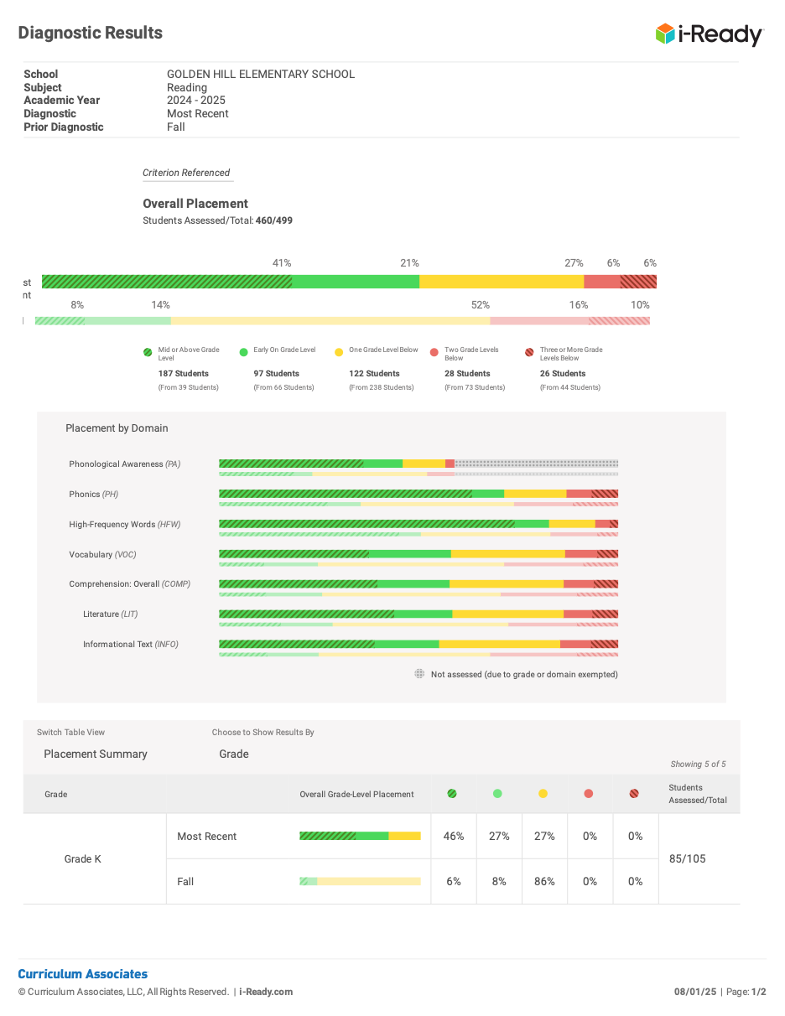

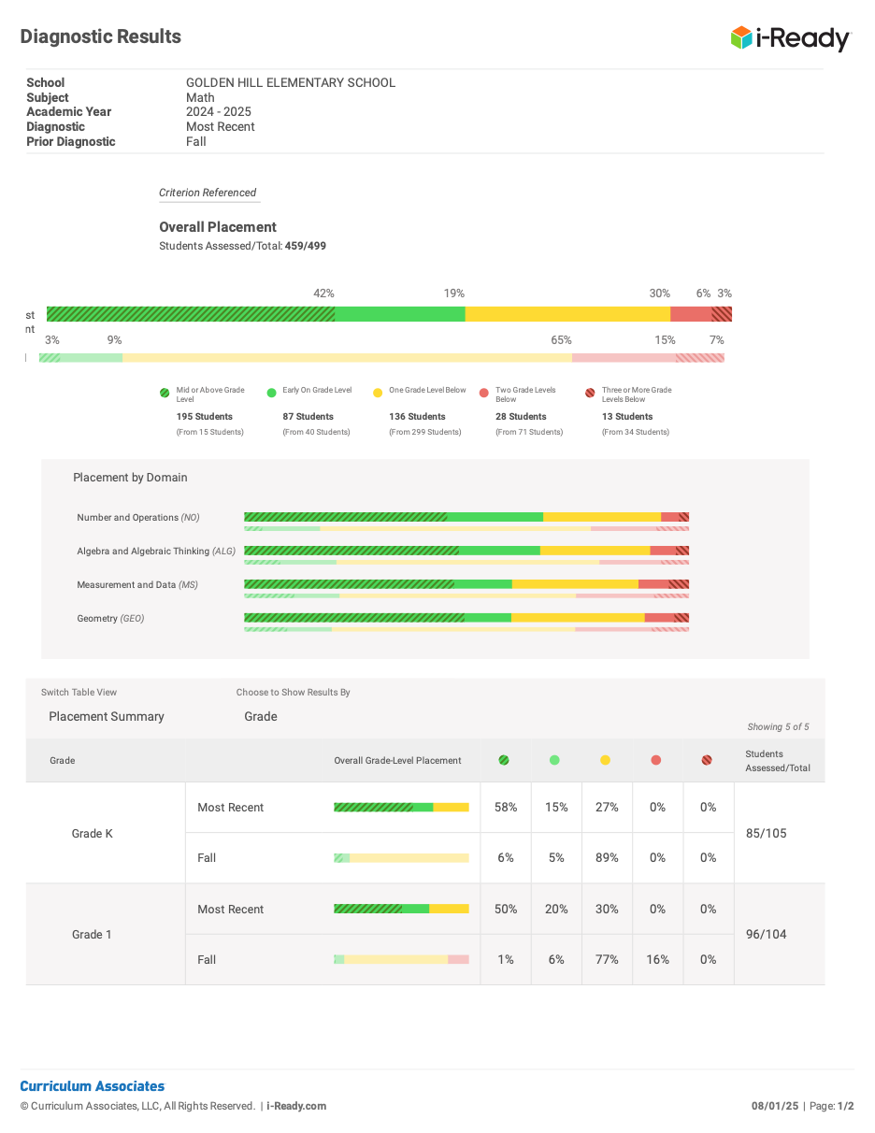

Capital Improvements: Optional

School Components required in accordance with Section 1114(b)(2)
- Annual Comprehensive needs assessment to gather feedback and determine areas of improvement based on student performance
- School-wide reform strategies that are inclusive and equitable to all subgroups.
- Instruction by highly qualified professional staff
- Professional Development for teachers, support staff, and paraprofessionals
- Strategies to attract highly qualified teachers
- Strategies to increase parent involvement
- Strategies for assisting students to the next level
- Steps to include teachers in the decision in regards to assessments
- Timely and effective assistance for students having difficulty meeting the proficient and advanced levels of performance (MTSS)
- Coordinate and integrate federal, state, and local programs and services.

Golden Hill Elementary School
School Site Council 2025-2026
SCHOOL COUNCIL MEMBERS, ROLES, SIGNATURES

CHAIRPERSON:
Paula Rodriguez SIGNATURE
Sara Hastings SIGNATURE

COCHAIR
Molly Antkowiak (teacher) SIGNATURE

RECORDING SECRETARY:
Robin Vinci (teacher)

TEACHERS:
Deborah Russell (teacher) SIGNATURE

PARENTS:
Danielle Hanagan 10 Coffin Ave SIGNATURE
Mikaela Lalumiere 88 Gary Ave SIGNATURE

COMMUNITY REPRESENTATIVE
Cathy Wolf-YMCA 81 Winter Street SIGNATURE
Jessica Kallin-Haverhill Promise 99 Main Street SIGNATURE

